EXPERIMENT – 1
AIM:
To create a simple cloud software application and provide it as a service using any Cloud Service Provider to demonstrate Software as a Service (SaaS).
PROCEDURE:
- A cloud service provider platform is selected to develop and host the application as Software as a Service (SaaS).
- A cloud application named “SIMATS Library Book Reservation System” is created to manage library book reservations online.
- A Book Details module is designed to store information such as book title, author, category, and availability status.
- A Student Details module is created to maintain student information required for book reservation.
- A Book Reservation module is implemented to allow students to reserve available books by selecting the book and student details.
- Dropdown fields are used in the application to maintain standardized data entry and reduce errors.
- All data entered through the application is stored securely in the cloud and can be accessed by authorized users.
- The application is deployed on the cloud and accessed through a web browser without installing any software.
OUTPUT:
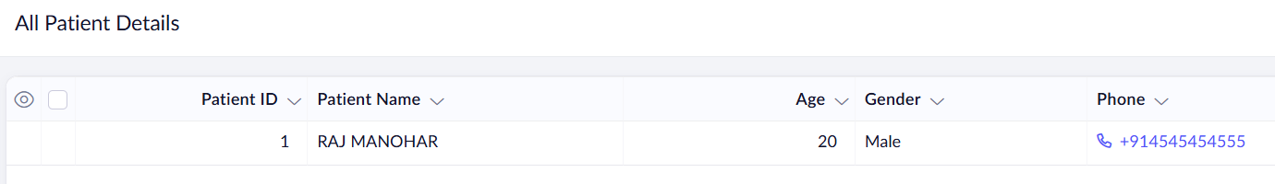

2.
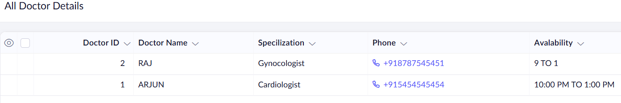
3.
